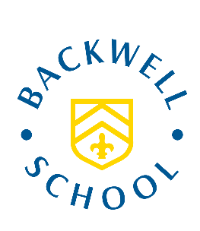

Transition Booklet July 2021

Induction Booklet for Year 6’s who will start at
Backwell School in September 2021

Name:

Primary/Junior School:

Welcome to Backwell School

Dear Year 6

A very warm welcome to Backwell School and the Transition Booklet that we have created for you.

I know these are very difficult times for everybody throughout our communities, but it is particularly challenging for students who will be moving to new schools in September, just like you Year 6’s. I know exactly how you are all feeling, as one of my sons is starting at a new school in September, so we are going through this transition process with him.

Unfortunately, we have not been able to have you come to visit Backwell School during Term 6, due to the guidelines and restrictions in place at the moment. So we have been looking at how we can help and support you in your transition to Backwell School. So, we have produced this Student Booklet for you to read through. In the booklet there are a few pages giving you some important information about our School, as well as a few little tasks for you to be doing. The tasks are aimed at getting you to think about how you are feeling about your move to Backwell and some questions that you will need to research by visiting our School website.

I hope you enjoy reading through the booklet and completing the tasks. I am really looking forward to meeting you all at our induction day on Monday 6 September.

Please take care of yourselves, your family and friends.

See you all soon!

Kind regards

Mr Stephens

Key Staff at Backwell School

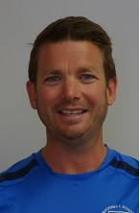
Mr Nunes, Headteacher
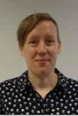

Mr Stephens - Assistant Headteacher and Pastoral Lead Year 7
Ms Donnelly: Assistant Headteacher and SENCO

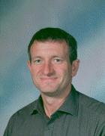
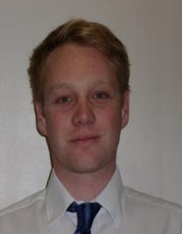
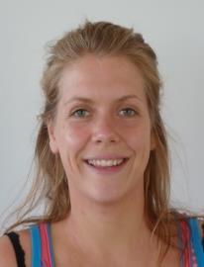
Mr Hooker: Year 7 Deputy

Mr Pritchard: Year 7 Deputy
Miss Cook: Year 7 Deputy
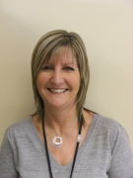

Mrs Cheeseman: Deputy Safeguarding Lead
Mr Sills: Assistant Headteacher and Safeguarding Lead
Former Backwell Year 7’s Thoughts and Feelings ….

‘When you join Backwell School people are happy to help you’
Ruby, Northleaze Primary School
‘Making new friends is really easy because there are so many new people to meet’
Lizzie, Court de Wyck Primary School

‘Teachers are always there for you if you struggle – don’t be afraid to ask.’
Hannah, St Francis Primary School
‘All the staff and really kind.’
Joel, Kingshill Primary School

‘It’s a really fun school’
Ed, Fairfield Primary School
‘The best things this year has been all the new and exciting opportunities I’ve had.’
Enya, Yatton Primary School

‘You make lots of friends’
Josepha, Flax Bourton Primary School

‘There are so many clubs and activities’
Eva, Kingshill Primary School
‘Backwell has given me more responsibility and stuff to do’
Molly, Wraxall Primary School
‘In Science you learn new things and do practical experiments.’
Milly, Backwell Junior School
The Normal School Day

Registration | 8.45 – 9.05 am
Period 1 | 9.05 – 9.55 am
Period 2 | 9.55 – 10.45 am
Break | 10.45 – 11.10 am
Period 3 | 11.10 – 12.00 pm
Period 4 | 12.00 – 12.50 pm
Lunch | 12.50 – 1.30 pm
Period 5 | 1.30 – 2.20 pm
Period 6 | 2.20 – 3.10 pm
The school day ends at 3.10 pm. All lessons are 50 minutes’ long, with some double lessons of 100 minutes.

Below is an example of a Year 7 timetable. Pretend this is your timetable next year (it won’t be, but just pretend it is!), and answer the questions below:
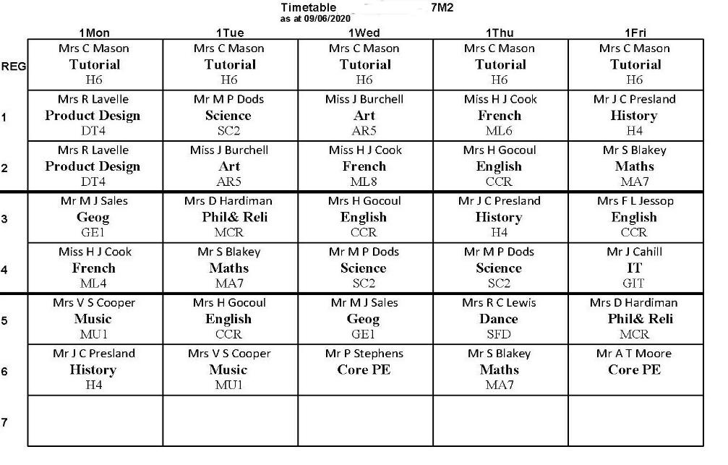

What subject do you have on Monday Period 3?
Who is teaching you Maths on Friday Period 2?
How many French lessons do you have in the week?
Which room is History taught in?

How many lessons do you have each day?
Registration

Every morning you start the day off in your Tutor Group with your Tutor
This is a time to;

- Check planners and uniform
- Independent reading
- Go to Year 7 assembly (once per week)
- Update Awards on Unifrog
- Exploring Relationships and Sex Education (RSE) topics
- Organise charity events
- Discuss issues for Backwell’s student council

And much more …….

How will I get to school?

Start to think and plan about your journey to school each day:

How am I travelling to school?

What time will I have to get up?

What time will I have to leave home?

How long will the journey take?

What time will I arrive at Backwell School?

What equipment should I have in my pencil case?

Write a list of the equipment you think you should have in your pencil case each day:

1
2
3
4
5
6
7

Home Learning

Home Learning at Backwell is what most people know as Homework. All your Home Learning tasks will be set on FROG, our student network. You should also write all homework down in your planners and hand it in on time. If you are unsure about your homework, please speak to your teacher when it is set or before it is due to be handed in.

In September you will have no Home Learning tasks for the first two weeks, this is to allow all students to settle into their lessons, before Home Learning starts. After two weeks you will then start to get Home Learning from our Core Subjects which are Maths, English and Science. As Term 1 then progresses other subjects will start to set their Home Learning tasks.

Below is a screen shot of some recently set Home Learning for a Year 7 Science lesson:

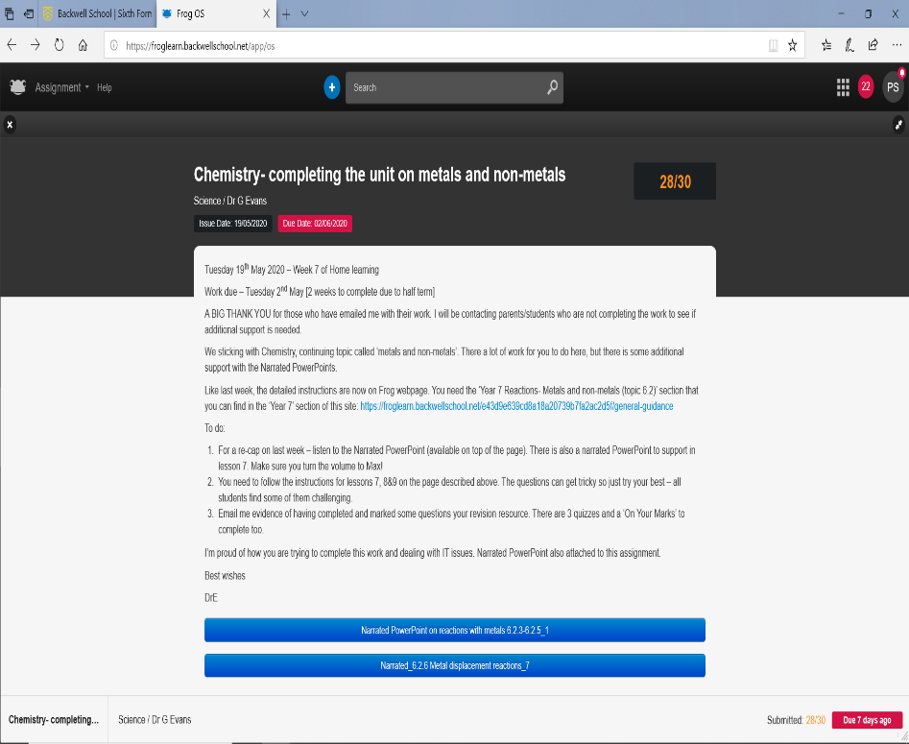

My Journey So Far

Life is a journey! Think back over your time at primary school and write down your favourite memories or events that have shaped you to become the amazing person that you are!

Your Thoughts on Transition

Please complete the questions below. They are aimed at getting you to think about your thoughts and feelings about starting at Backwell in September.

What are you looking forward to about starting at Backwell School?
What are your thoughts/feelings about leaving your Primary/Junior School?
Is there anything that is worrying about your start at Backwell? YES / NO
If yes, please explain your concerns.
Please write a couple of interesting facts about yourself, which your new tutor can read.
What are your main interests and hobbies outside of school?
Think of a couple of questions you may want to ask your tutor on the first day at school in September.

Getting to know Backwell School

Backwell School has its own website that holds lots information about the school. To get to know more about our school we would like to visit our website at
https://www.backwellschool.net/

Below we have given you a number of questions – all the answers can be found on our school website. So go onto the website and begin to navigate (move around) the website trying to find the answers to the questions. All the answers can be found in one of the seven tabs on the home screen. The tabs are called – Home, About Us, Information, Students, Parents, Curriculum, Sixth Form and Latest News & Events. Under these eight tabs are sub-headings which you will have to look through to find the answers.

I will direct you to the correct tab to find the answer, then you have to look through each sub heading. If you can’t find any answers please don’t worry, just leave the answer blank. The important thing is to have a look around the website.

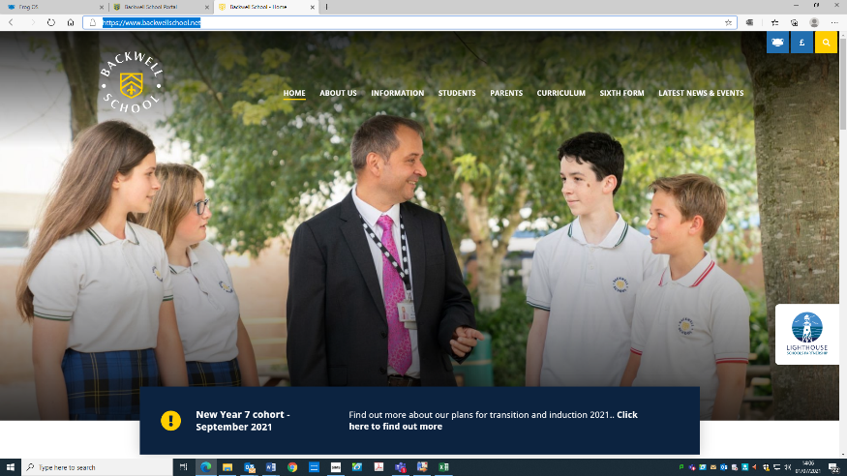

So now how a go at answering the questions in the table on the next page. Good luck!

Question | Answer
What are the names of the six Assistant Headteachers? (About Us)

Who is the Assistant Headteacher in charge of Year 7 and Key Stage 3 (About Us)

Who is the Designated Safeguarding Lead at the school? (About Us)

Who is Head of Cotswold House (About Us)

Name three foods you can buy from the ‘Grab and Go’ offer (Information)

How much does it cost to hire the Sports Hall from 5.00 – 6.00 pm? (Information)

How many Year 13 student have got a place at Oxford University? (Curriculum)

What are the names of the three ladies who work in the school library? (Curriculum)

Who is the Careers Leader in school (Students)

Where do you go to find lost property (Students)

Which teacher runs the Monday online Chess Club? (Students)

How much does it cost to hire a school locker for the year? (Students)

Looking Smart at Backwell School

At Backwell School we take pride in our school uniform and like to look smart at all times. Using the uniform page of the school website draw and label the school uniform you will wear at Backwell onto the Lego person below. Make sure you use the correct House colour for the stripe on the jumper and the collar of the polo shirt! You will have been told which House you are going to join.
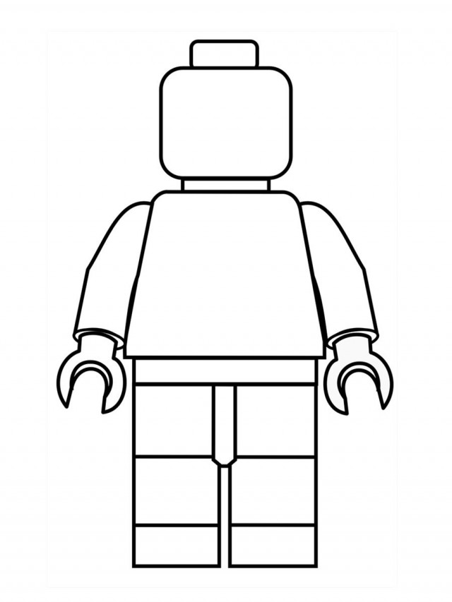

Why is wearing the correct school uniform important?

Subjects at your New School

C | R | M | A | F | Y | F | N | Z | H | P | G | U | P | C | F
O | Q | T | U | T | O | R | T | I | M | E | J | S | K | A | R
M | Z | T | E | V | M | S | P | A | N | I | S | H | V | O | E
P | A | B | H | X | Y | I | M | C | N | Z | R | D | H | N | N
U | Z | T | A | J | T | H | T | S | X | D | R | R | B | Q | C
T | W | Y | H | S | B | I | Y | B | S | A | E | A | Y | L | H
I | N | Z | R | S | P | S | L | V | J | K | L | M | Y | I | M
N | H | N | B | T | R | T | G | E | O | G | R | A | P | H | Y
G | I | C | R | X | Q | O | B | S | S | B | Q | P | V | L | S
Z | B | A | K | N | S | R | R | X | W | I | E | T | B | A | O
Y | B | S | A | E | Q | Y | L | L | D | V | J | M | Q | Z | P
S | S | C | I | E | N | C | E | X | D | R | E | B | N | W | L
M | W | A | J | F | C | T | H | M | U | S | I | C | K | D | M
E | N | G | L | I | S | H | U | I | S | Z | M | N | B | T | S
B | N | W | L | K | N | S | J | A | P | Q | L | T | P | N | E
D | E | S | I | G | N | T | E | C | H | N | O | L | O | G | Y

Maths | History | French | Spanish
English | Computing | Art | PE
Science | Music | Textiles | Assembly
Geography | Design Technology | Drama | Tutor Time

My goals for secondary schools

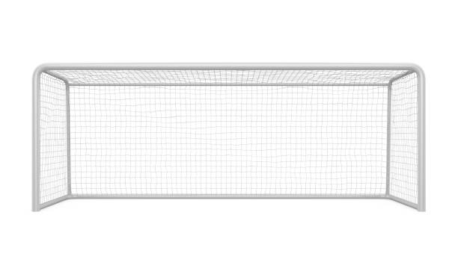
When you come to Backwell School you will learn a lot of new skills and improve skills that you have learnt in Primary School. In the goal below, use the list of suggestions to write in ten new skills or things you would like to build on in your years at secondary school, or maybe add some of your own!

Be in a school play or production | Speak another language | Cook a new meal from scratch
Learn to play a musical instrument | Travel to another country | Take part in a fancy dress day
Play for a school team | Learn how to manage money | Represent your school in a national competition
Read new books | Join one of the school’s orchestras or groups | Raise money for charity
Become Head Student | Learn how to read a map | Join an after school club
Learn to dance | Learn First Aid | Use computers to make your own website
Make new friends from other schools | Improve your singing | Work as part of a team
Taste food from another country | Help look after the school vegetable garden | Create a piece of art

Where Am I? Map of the School

Ground Floor Classrooms and Areas

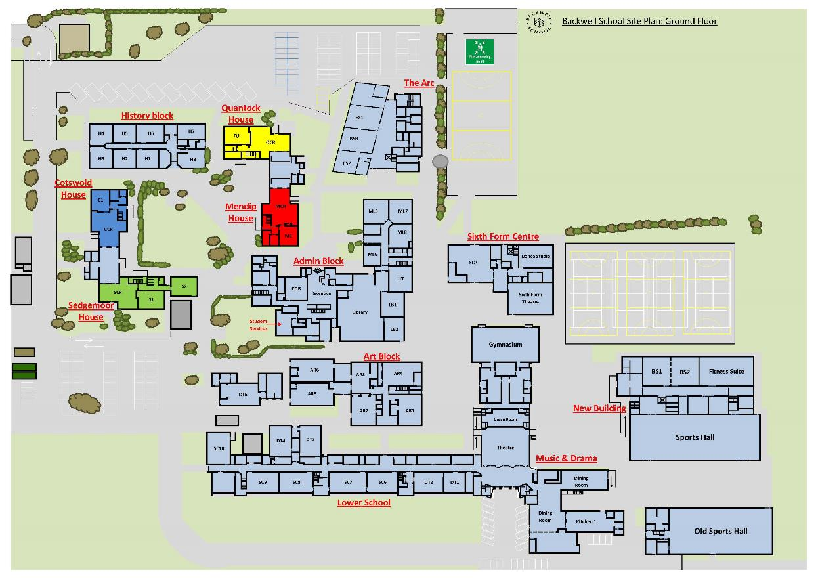

Where Am I? Map of the School

First Floor Classrooms

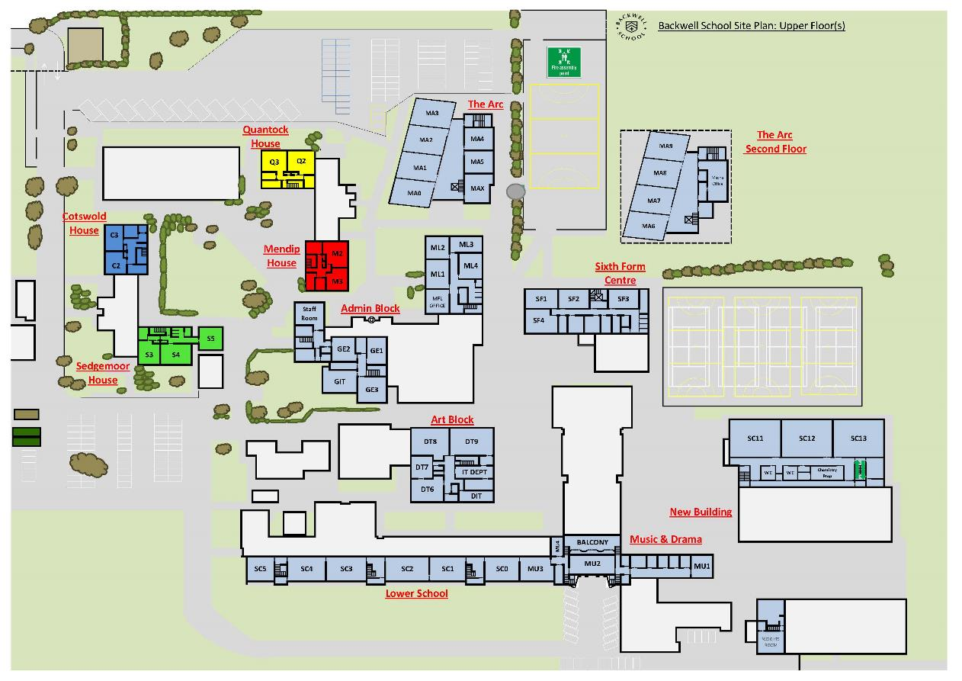

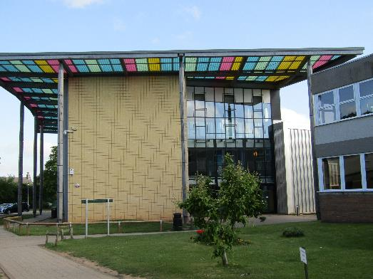

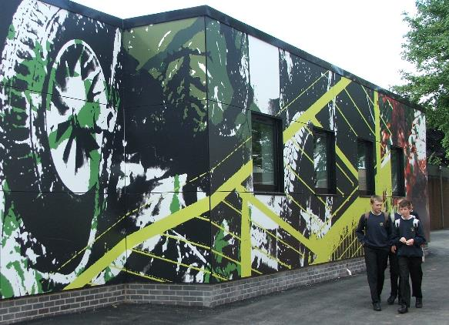

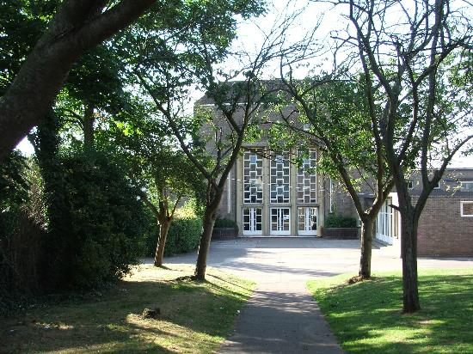

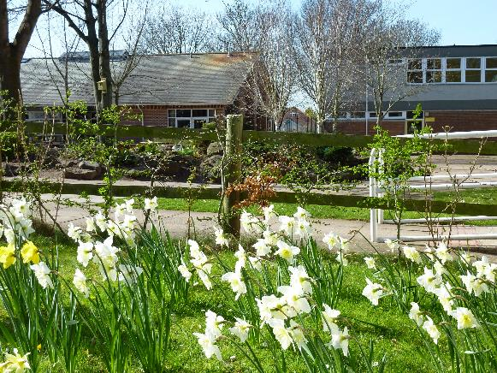

We look forward to seeing
you soon!

